

**Polling District and Polling Place Review 2025**

**Manor Park Ward**

**Parliamentary Constituency:** East and Wallsend

**(Proposed) Polling Districts:** Q01, Q02, Q03, Q04, Q05

The Local Government Boundary Commission for England are an independent body accountable to Parliament. They are responsible for reviewing councils to make sure their patterns of internal wards are fair and sensible. Their reviews include at least two rounds of public consultation before they make recommendations for change.

The final recommendations were published on 7 January 2025, and the new arrangements apply to local elections from 2026.

As a result of changes to ward boundaries the Acting Returning Officer (ARO) is conducting a review of polling districts and polling places to ensure that they are suitable for the new ward boundaries.

For more information on the local government boundary review visit: <https://www.lgbce.org.uk/all-reviews/newcastle-upon-tyne>

This document provides details of the review, along with the initial recommendations and comments of the Acting Returning Officer (ARO). Also, the election rules require the ARO to decide how many polling stations are required for each polling station and the ARO must allocate electors to the polling stations in such manner as they think most convenient.

These recommendations will be open to all residents, stakeholders, and any interested parties. We shall be seeking representations from local disability groups on the accessibility and suitability of polling places. Any comments should be addressed in the first instance to pollingplaces@newcastle.gov.uk where they will be collated on behalf of the (Acting) Returning Officer.

We considered the following factors:

* **Identifying new polling places:** We will look for new polling places in areas where the existing provision is unsuitable or unavailable.
* **Feedback:** We will consider feedback received following recent elections, consultation from members of the public, elected members, and other stakeholders.
* **Accessibility:** We will try to ensure that every polling place is accessible to electors with disabilities.
* **Facilities**: We will make sure that all electors have such reasonable facilities for voting as are practicable in the circumstances.
* **Elector numbers:** We will try to comply with the Electoral Commission guidance on the maximum number of electors that should be allocated to a polling station which should not exceed 2,250.
* **Future housing developments**: We will consider the impact of proposed housing developments on polling station electorates.

**(Current) Manor Park Ward**

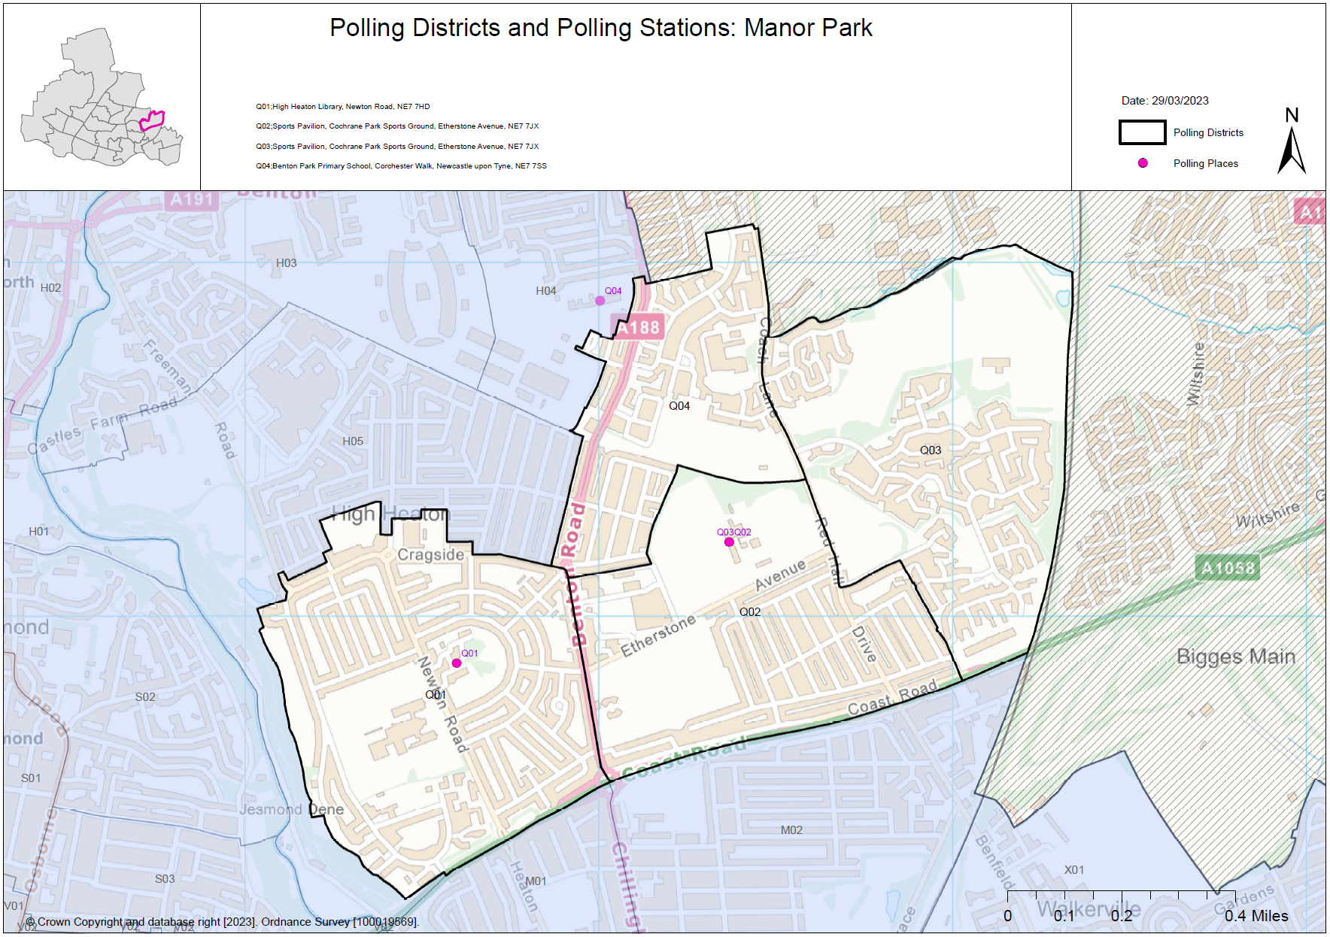This map shows the current ward and polling district boundaries and the polling place.

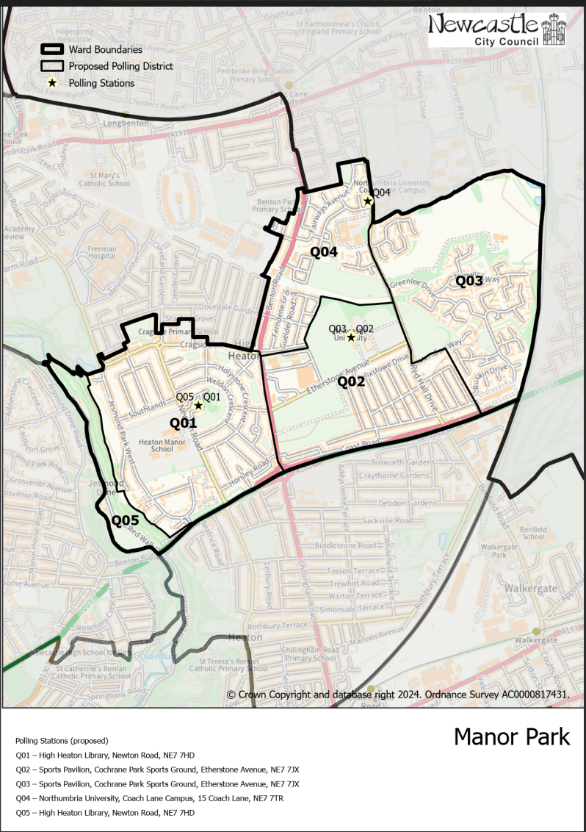**(New)**

**Manor Park Ward**

This map shows the new ward and the proposed polling districts and the proposed polling places.

* **Q01**

High Heaton Library, Newton Road, NE7 7HD

* **Q02**

Sports Pavilion, Cochrane Park Sports Ground, Etherstone Avenue, NE7 7JX

* **Q03**

Sports Pavilion, Cochrane Park Sports Ground, Etherstone Avenue, NE7 7JX

* **Q04**

Northumbria University, Coach Lane Campus, 15 Coach Lane, NE7 7TR

* **Q05**

High Heaton Library, Newton Road, NE7 7HD

**Manor Park Ward**

**Polling District Q01**

|  |  |
| --- | --- |
| **Current Polling District** | **Current Polling Place** |
| Q01 (full) | High Heaton Library, Newton Road, NE7 7HD |

|  |  |  |
| --- | --- | --- |
| **Proposed Polling District** | **Predicted**  **Polling Station Electorate** | **Proposed Polling Place** |
| Q01 | 1565 | High Heaton Library, Newton Road, NE7 7HD |

|  |
| --- |
| **Considerations and Proposals** |
| No changes to the polling district boundary.  No change to the polling place. High Heaton Library is suggested as a double polling station for the proposed districts of Q01 and Q05. |

|  |
| --- |
| **Preliminary Consultation – Elected Members comments and feedback** |
| No comments received. |

**Manor Park Ward**

**Polling District Q02**

|  |  |
| --- | --- |
| **Current Polling District** | **Current Polling Place** |
| Q02 (full) | Sports Pavilion, Cochrane Park Sports Ground, Etherstone Avenue, NE7 7JX |

|  |  |  |
| --- | --- | --- |
| **Proposed Polling District** | **Predicted**  **Polling Station Electorate** | **Proposed Polling Place** |
| Q02 | 916 | Sports Pavilion, Cochrane Park Sports Ground, Etherstone Avenue, NE7 7JX |

|  |
| --- |
| **Considerations and Proposals** |
| No changes to the polling district boundary.  No change to the polling place. Sports Pavilion, Cochrane Park is suggested as a double station for the proposed districts of Q02 and Q03. |

|  |
| --- |
| **Preliminary Consultation – Elected Members comments and feedback** |
| No comments received. |

**Manor Park Ward**

**Polling District Q03**

|  |  |
| --- | --- |
| **Current Polling District** | **Current Polling Place** |
| Q03 (full) | Sports Pavilion, Cochrane Park Sports Ground, Etherstone Avenue, NE7 7JX |

|  |  |  |
| --- | --- | --- |
| **Proposed Polling District** | **Predicted**  **Polling Station Electorate** | **Proposed Polling Place** |
| Q03 | 748 | Sports Pavilion, Cochrane Park Sports Ground, Etherstone Avenue, NE7 7JX |

|  |
| --- |
| **Considerations and Proposals** |
| No changes to the polling district boundary.  No change to the polling place. Sports Pavilion, Cochrane Park is suggested as a double station for the proposed districts of Q02 and Q03. |

|  |
| --- |
| **Preliminary Consultation – Elected Members comments and feedback** |
| No comments received. |

**Manor Park Ward**

**Polling District Q04**

|  |  |
| --- | --- |
| **Current Polling District** | **Current Polling Place** |
| Q04 (full) | Benton Park Primary School, Corchester Walk, NE7 7SS |

|  |  |  |
| --- | --- | --- |
| **Proposed Polling District** | **Predicted**  **Polling Station Electorate** | **Proposed Polling Place** |
| Q04 | 1033 | Northumbria University, Coach Lane Campus, 15 Coach Lane, NE7 7TR |

|  |
| --- |
| **Preliminary Consultation – Elected Members comments and feedback** |
| **Cllr Wendy Taylor**  “Your suggestion for G04 (Benton Lodge area) isn’t in the polling district or even in Dene and South Gosforth ward so I don’t understand why it has been suggested”.  “Perhaps we could look at a shop at Four Lane Ends or Sutherland Park Rugby Club (Disabled access could be a problem there). Otherwise, would a portacabin not be possible as a temporary measure”. |

|  |
| --- |
| **Considerations and Proposals** |
| No changes to the polling district boundary.  The existing polling place is Benton Park Primary School, which is currently closed for refurbishment.  Northumbria University is suggested as a double polling station for the proposed G04 and Q04 districts.  Novocastrians RFC is a proposal, requires site visit. |

**Manor Park Ward**

**Polling District Q05**

|  |  |
| --- | --- |
| **Current Polling District** | **Current Polling Place** |
| H05 (part of) | St George’s United Reformed Church, Boundary Gardens, NE7 7HP |

|  |  |  |
| --- | --- | --- |
| **Proposed Polling District** | **Predicted**  **Polling Station Electorate** | **Proposed Polling Place** |
| Q05 | 0 | High Heaton Library, Newton Road, NE7 7HD |

|  |
| --- |
| **Considerations and Proposals** |
| This is a new district which was part of the current H05 district within Dene and South Gosforth ward.  The closest polling station for this area is High Heaton Library. High Heaton Library is suggested as a double polling station for the proposed districts of Q01 and Q05. |

|  |
| --- |
| **Preliminary Consultation – Elected Members comments and feedback** |
| No comments received. |

THIS PAGE IS INTENTIONALLY BLANK